**Lab Practical #02:**

Study of different types of network cables & connectors and crimping a LAN.

**Practical Assignment #02:**

1. List various networks cable. Also, write short description.
2. Difference between guided and unguided media.
3. Give cross-wired cable and straight through cable diagram (Color Code wise).

## List various networks cable and connectors. Also, write short description.

**a) Twisted Pair Cable**:

* **Description**: Twisted pair cables consist of pairs of wires twisted together to reduce electromagnetic interference. Common types are Unshielded Twisted Pair (UTP) and Shielded Twisted Pair (STP).
* **Diagram**:

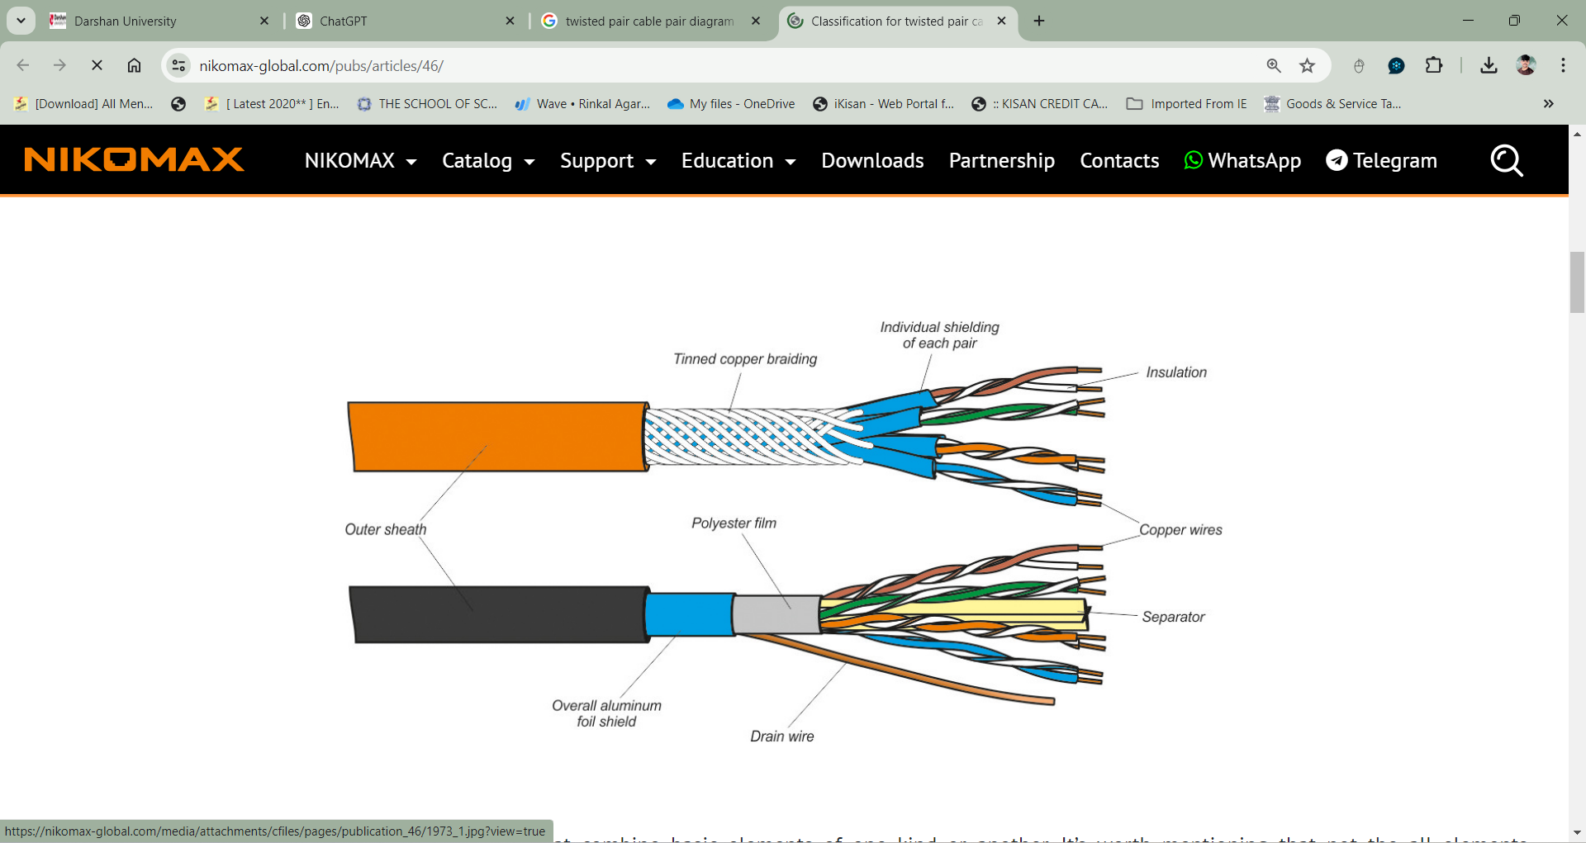

**b) Coaxial Cable**:

* **Description**: Coaxial cables have a central conductor, an insulating layer, a metallic shield, and an outer insulating layer. They are commonly used for cable television and broadband internet.
* **Diagram**:

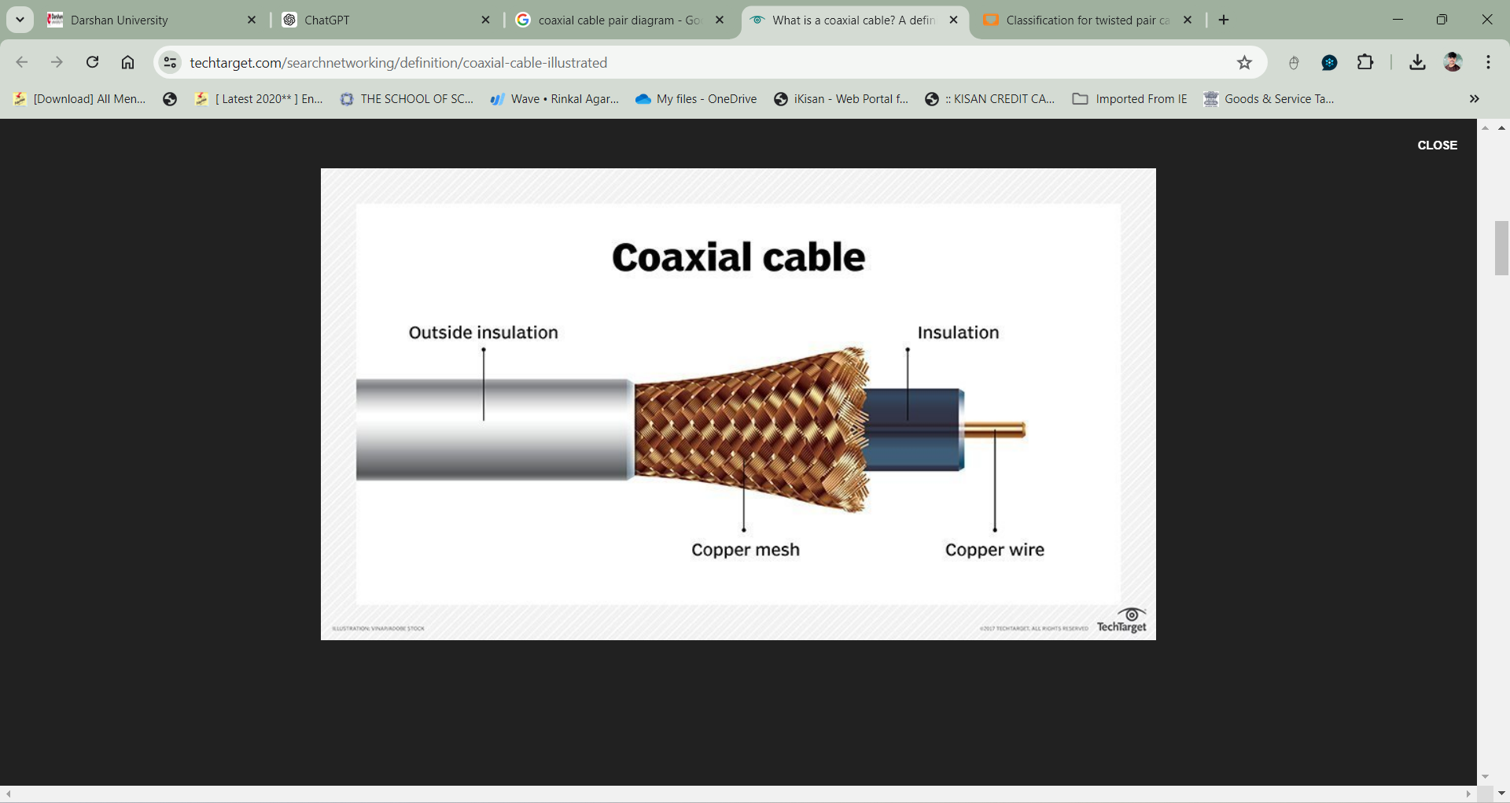

**c) Fiber Optic Cable**:

* **Description**: Fiber optic cables use light to transmit data. They have a core made of glass or plastic fibres, surrounded by a cladding and protective layer. They provide high bandwidth and long-distance data transmission.
* **Diagram**:

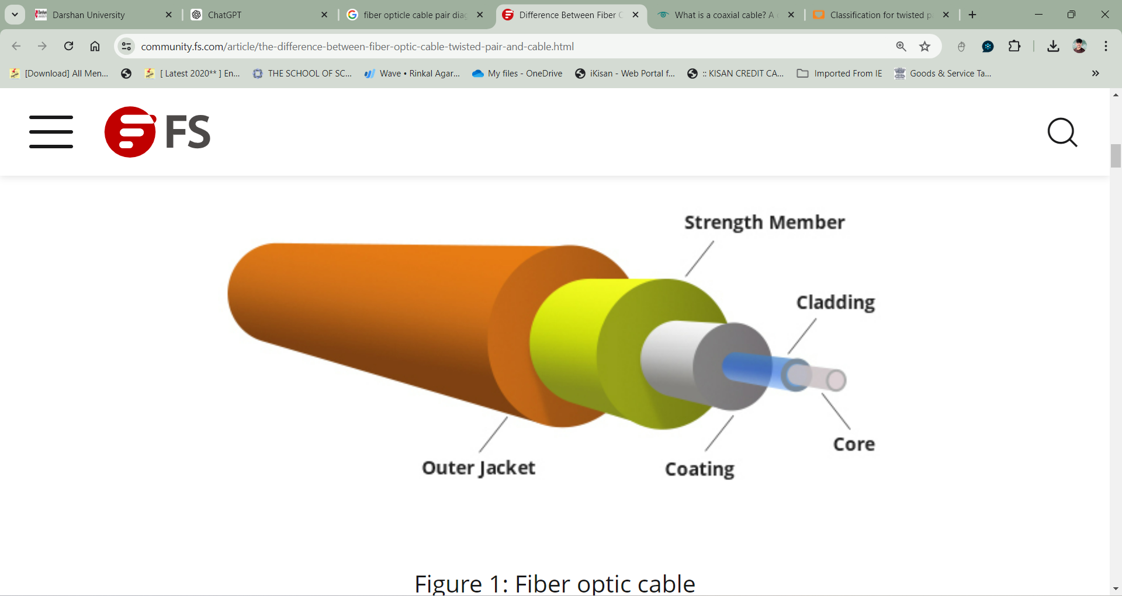

1. **Difference between guided and unguided media.**

* **Guided Media**:
* **Description**: Guided media are transmission mediums that provide a physical path for signal transmission. Examples include twisted pair cables, coaxial cables, and fiber optic cables.
* **Examples**: Ethernet cables, telephone lines, fibre optic cables.
* **Unguided Media**:
* **Description**: Unguided media are transmission mediums that do not provide a physical path. They transmit data through the air or space. Examples include radio waves, microwaves, and infrared signals.
* **Examples**: Wi-Fi, satellite communication, Bluetooth.

## Give cross-wired cable and straight through cable diagram (Color Code wise).

1. Cross-wired Cable Diagram (Color Code)

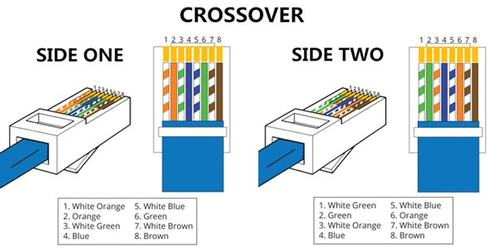

1. Straight Through Cable Diagram (Color Code)

